**COMPARATIVE STUDY ON EFFECTS OF TEARFILM PARAMETERS OF EYELINER & MASCARA USERS AND NON-USERS AMONG YOUNG ADULTS**

***A Dissertation submitted to***



***Submitted in partial fulfilment of the requirements for the award of degree of***

###### BACHELOR OF SCIENCES IN OPTOMETRY

***By*,**

JEVITHA SRI. S INTERN - B.Sc. (optometry) SNEHA.K INTERN- B.Sc.(optometry) KARTHIK.S - INTERN B.Sc.(optometry) PAPPI BACHA- INTERN B.Sc.(optometry) PREETHI.M- INTERN B.Sc.(optometry VIDHYA.V- INTERN B.Sc.(optometry)

#### **FACULTY OF ALLIED HEALTH SCIENCES**

**Under the guidance of**

#### **Mr. MAGESHWARAN. E, M.Optom FACULTY OF ALLIED HEALTH SCIENCES**

**Dr. M.G.R. EDUCATIONAL AND RESEARCH INSTITUTE**

***(Deemed To Be University)***

#### **VELLAPANCHAVADI, CHENNAI**

**DECLARATION BY THE CANDIDATES**

We hereby declare that the work incorporated in the thesis entitled - **COMPARATIVE STUDY ON EFFECTS OF TEARFILM PARAMETERS OF EYELINER & MASCARA USERS AND NON-USERS AMONG YOUNG ADULTS** prepared by at **DR. M. G. R. Educational And Research Institute**, Chennai, under the guidance and supervision of **Mr. Mageshwaran. E, M.Optom., Faculty of Allied Health Science, DR.** M. G. R. Educational And Research Institute.

This dissertation is submitted to **DR. M. G. R. Educational And Research Institute** in partial fulfilment of the University Regulation for the award of the Degree of Bachelor of Sciences (Optometry)

Place: Signature of the candidates

Date:

JEVITHA SRI. S

**(196041105072)**

KARTHIK.S

**(196041105073**)

PAPPI BACHA

**(196041105076)**

PREETHI.M

**(196041105079)**

SNEHA.K

**(196041105083)**

VIDHYA.V

**(196041105085)**

#### **CERTIFICATE BY THE GUIDE**

This is to certify that this dissertation entitled- **COMPARATIVE STUDY ON EFFECTS OF TEARFILM PARAMETERS OF EYELINER & MASCARA USERS AND NON-USERS AMONG YOUNG ADULTS** has been prepared under my supervision and is being submitted to **DR. M. G. R. Educational And Research Institute Chennai,** in Partial Fulfilment of the university regulation for the award of the Degree of bachelor of Science in Optometry and their dissertation is a bonafide work.

Date: Signature of the guide

The Head of the Department The Principal The Director

**ACKNOWLEDGEMENT**

###### Our gratitude and thanks to our FOUNDER-CHANCELLOR THIRU A.C. SHANMUGAM, B.A., B.L., PRESIDENT ER. A.C.S. ARUNKUMAR, B.TECH, MBA, SECRETARY THIRU. A. RAVIKUMAR, M.B.A., AND VICE CHANCELLOR PROF.

**DR. S. GEETHALAKSHMI, M.D., Ph.D.,** of DR. M.G.R. Educational and Research Institute.

We would like to sincerely thank **DR. KALAVATHY VICTOR. H, DIRECTOR, FACULTY OF AHS,** for her continuous guidance and support during the project work.

We would like to thank our beloved **DR. KALPANA DEVI, PRINCIPAL, FACULTY OF AHS,** for her continuous motivation during the project work.

We would like to thank our beloved **DR. KANMANI, HEAD OF THE DEPARTMENT, DEPARTMENT OF OPHTHALMOLOGY,** for his continuous motivation during the study.

We deeply thank Our Guide and Project Supervisor, **MR. MAGESHWARAN. E,** for his valuable guidance, encouragement and suggestions throughout the work.

We wish to express our sincere thanks to **MR. JONES EBEN RAJ. T (LECTURER IN ANATOMY), MRS. MERLIN. G (LECTURER IN BIOSTATISTICS) AND MRS.**

**JEEVA JYOTHI (LECTURER IN BIOSTATISTICS),** who also helped us in analysing data, through which we could complete our work soon.

Our heartfelt gratitude to the faculties of optometry‘s other instructors, **MR. SUDESAN AND MS. GOMATHY,** for having such faith in us, extending valuable knowledge and supporting us throughout the course.

With a sense of profound gratitude and indebtedness, we wish to thank **MRS. MOHANA PRIYA and MS. PRIYADHARSHINI,** in charge of Refraction unit for their patience, thoughtful advice and for putting up with all our shortcomings.

We express our sincere thanks to **ALL THE STAFFS AND DOCTORS IN OPHTHALMOLOGY DEPARTMENT;** for helping us with their extensive knowledge.

We would like to extend our sincere thanks to **ALL OUR FRIENDS AND COLLEAGUES** who has stayed by our side through all our difficulties and without them our project would have remained incomplete.

We specially thank our three friends **THIRISHA. R, SIVA MUTHU. A AND YOGESHWARI. K ,** who have willingly helped us out with their abilities during the project.

We are indebted to **OUR PARENTS, AND THE REST OF OUR WONDERFUL**

**FAMILY**, for their constant prayers, words of encouragement and unwavering love. We thank all the **PARTICIPANTS** for their cooperation & participation in this study.

# CONTENTS

**CONTENT**

|  |  |  |
| --- | --- | --- |
| **S.NO** | **CONTENT** | **PG.NO.** |
| **1** | **INTRODUCTION** |  |
| **2** | **REVIEW OF LITERATURE** |  |
| **3** | **AIMS AND OBJECTIVE** |  |
| **4** | **MATERIALS AND METHODOLOGY** |  |
| **5** | **RESULTS** |  |
| **6** | **DISCUSSION** |  |
| **7** | **CONCLUSION** |  |
| **8** | **BIBLIOGRAPHY** |  |
| **9** | **ANNEXURE** |  |

## **INTRODUCTION**

### **1.INTRODUCTION:**

#### TEAR FILM

The ocular surface is covered by a thin fluid coating called the tear film. It maintains the health of the epithelium, the comfort of the ocular surface, mechanical, immunological, and environmental protection, and it creates a smooth refractive surface for vision. The surface chemical properties of the tear film system and the proper operation of the lacrimal apparatus regulate the circumstances of tear film generation and stability. To perform its purpose, the tear film must be continuous in between blinks. The tear film is approximately 3 to 10 μL in volume, 3 μm thick, and secreted at a rate of 1 - 2 μL/min.**10**

**The tear film is a thin, fluid layer that covers the ocular surface. The epithelium, ocular surface, mechanical, and immunological systems are all kept in good shape by this. Smooth refractive surfaces are produced for vision thanks to andensirenmental protection. The conditions of tear film generation and stability are dependent on the surfacechemical properties of the tear film system and the proper operation of the lacrimal apparatus. The tear film must to run continuously between blinks in order to serve its purpose. Approximate tear film dimensions are 3 um thick, 3 um in volume, and 1-2 uL/min in secretion rate**

###### LAYERS OF TEAR FILM

Although the tear film milieu may be oversimplified, these components—lipid, aqueous, and mucin—are frequently described as layers.**11** The lipid layer, which is the most superficial

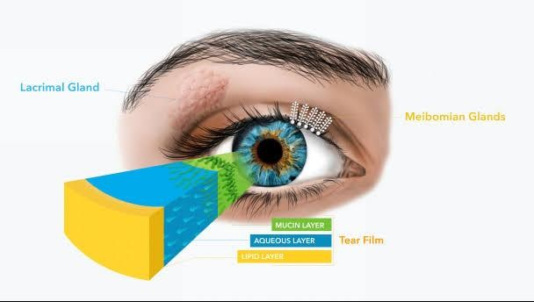

###### Figure 1.2.1 layers of tear film

layer, is produced by the meibomian glands of the eyelids and serves to slow down the evaporation of tears.The lacrimal glands, which are found in the orbits, and the accessory lacrimal glands (the Krause and Wolfring glands) in the conjunctiva create the middle aqueous layer, which is the thickest part of the tear film. Conjunctival goblet cells primarily create the mucins, or glycoproteins, that make up the basal layer. Through the control of surface tension, mucins facilitate the tear film spreading over the corneal epithelium.**12**

###### TFOS DEWS II CLASSIFICATION OF TEAR FILM LAYERS

**Figure 1.2.2.**

###### DEWS II classification of tear film layers

Traditionally, the tear film was defined as a three-layered structure composed of a mucin layer, an aqueous layer, and a lipid layer. The TFOS DEWS II, on the other hand, displays the tear film as a two-layered interacting structure with a mucoaqueous layer and a lipid layer.

The lipid layer helps to lower surface tension, prevent evaporation, and stabilize tear films while the mucoaqueous layer helps to reduce friction and hydrate the ocular surface. Each blink promotes capillary movement and upward drift of the lipid and mucoaqueous layers, which aids in tear distribution throughout the corneal and conjunctival surfaces.**11**

###### FUNCTIONS OF TEAR FILM

* + - * Maintains the moisture of the cornea and conjunctiva.
      * Oxygenates the corneal epithelium.
      * Removes dirt and harmful irritants.
      * Prevents infection due to the presence of anti-bacterial substances.
      * Enables the lids to glide more easily over the globe.

###### TEAR FUNCTION TEST Schirmers 1 test:

Total tear secretion is measured by the schirmers test. The procedure is carried out using a 5 x 35 mm piece of Whatman 41 filter paper that has been folded 5 mm from one end and placed in the lower fornix at the intersection of the lateral one third and medial two thirds. Normal individuals tend to have Schirmer test I values > or = 10 mm in 2 minutes, irrespective of age and gender.**13**

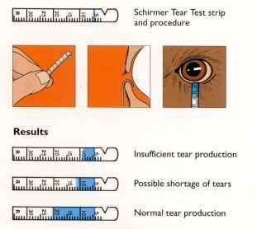

###### Figure 1.2.4. (i) Schirmer test

**TBUT (Tear film break up time):**

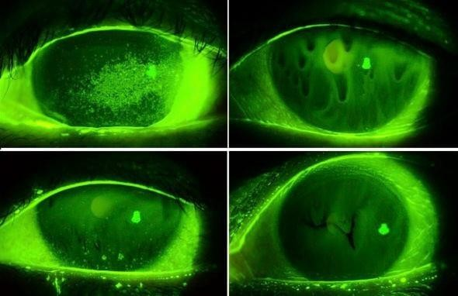A common, accepted test for determining the stability of tear films is the tear film break-up time. It is a period of time between the first randomly distributed dry spot on the cornea and the completion of a blink. TBUT readings in healthy eyes range from 3 seconds to 132 seconds, with an average of 27 seconds. Less than 5 s is indicative of dry eye, while values between 5 and 10 s are considered marginal. TBUT less than 10 s suggest an abnormal tear film.

###### Figure 1.2.4. (ii)

**Appearance of dry spot (TBUT)**

###### Vital staining:

The tear film that covers the epithelium is normally not visible due to the cornea's regular, smooth, and shiny surface. Ocular tissues have also been subjected to the histology principle of making transparent structures visible through the admixture of dyes. The cornea and conjunctiva have been vitally stained with a variety of dyes, including fluorescein, rose bengal, lissamine green, alcian blue, scarlet red, etc.